**Global COVID-19 Impact Analysis: Mortality Trends, Regional Comparisons & Vaccination Insights**

**Project Overview:**

This project delivers a comprehensive and data-driven exploration of the global COVID-19 pandemic, emphasizing **mortality trends**, **regional disparities**, and **vaccination rollout dynamics**. Leveraging authoritative data from the **World Health Organization (WHO)** and **Our World in Data**, the analysis uncovers key epidemiological patterns and informs public health strategies.

**Key Deliverables & Analytical Insights:**

🔹 **Temporal Mortality Trends**

* Modeled daily new confirmed COVID-19 deaths per million across leading nations.
* Identified and visualized pandemic wave patterns using advanced time-series analysis.
* Assessed the effectiveness of containment measures and vaccination on reducing mortality.

🔹 **Global and Regional Mortality Distribution**

* Segmented cumulative COVID-19 deaths by continents and regions.
* Highlighted disproportionate mortality impacts in Europe, North America, and South America.
* Explored factors contributing to lower mortality rates in Africa and Oceania through contextual data overlays.

🔹 **Vaccination Progress Assessment**

* Tracked and compared vaccination coverage globally by country and region.
* Visualized first-dose vs. full vaccination rates using proportional and trend-based plots.
* Identified rollout bottlenecks and regional disparities in vaccine accessibility and uptake.

🔹 **Statistical & Epidemiological Analysis**

* Performed correlation analysis between vaccination rates and mortality decline.
* Conducted hypothesis testing to validate the significance of regional variation in death rates.
* Applied regression models to forecast short-term mortality based on vaccination metrics and public health interventions.

🔹 **Data Engineering & Processing**

* Extracted and transformed large-scale datasets using **SQL** and **Excel-based data pipelines**.
* Designed modular and reproducible workflows for public health data analysis.
* Ensured data integrity and clarity through rigorous preprocessing, aggregation, and normalization.
* **SQL Proficiency:** Writing complex queries for data cleaning, aggregation, and analytical computations. **Statistical Analysis:** Deriving meaningful insights from raw data to calculate key performance indicators like death rates and infection percentages.
* **Data Visualization (Implied by the 'Results' tables):** Presenting analytical outcomes in a clear and organized manner.

**Tools & Technologies:**SQL · Excel · Statistical Analysis · Time Series Modelling · Data Cleaning & ETL · Our World in Data APIs

**Impact & Applications:**This project illustrates how rigorous data analysis and visualization can be harnessed to guide real-time decision-making during global crises. It serves as a **blueprint for data scientists, public health analysts, and policymakers** seeking to understand and respond to the multifaceted challenges of pandemic dynamics.

**Daily new confirmed COVID-19 deaths per million people:**

7-day rolling average. Due to varying protocols and challenges in the attribution of the cause of death, the number of confirmed deaths may not accurately represent the true number of deaths caused by COVID-19.

**Chart :**

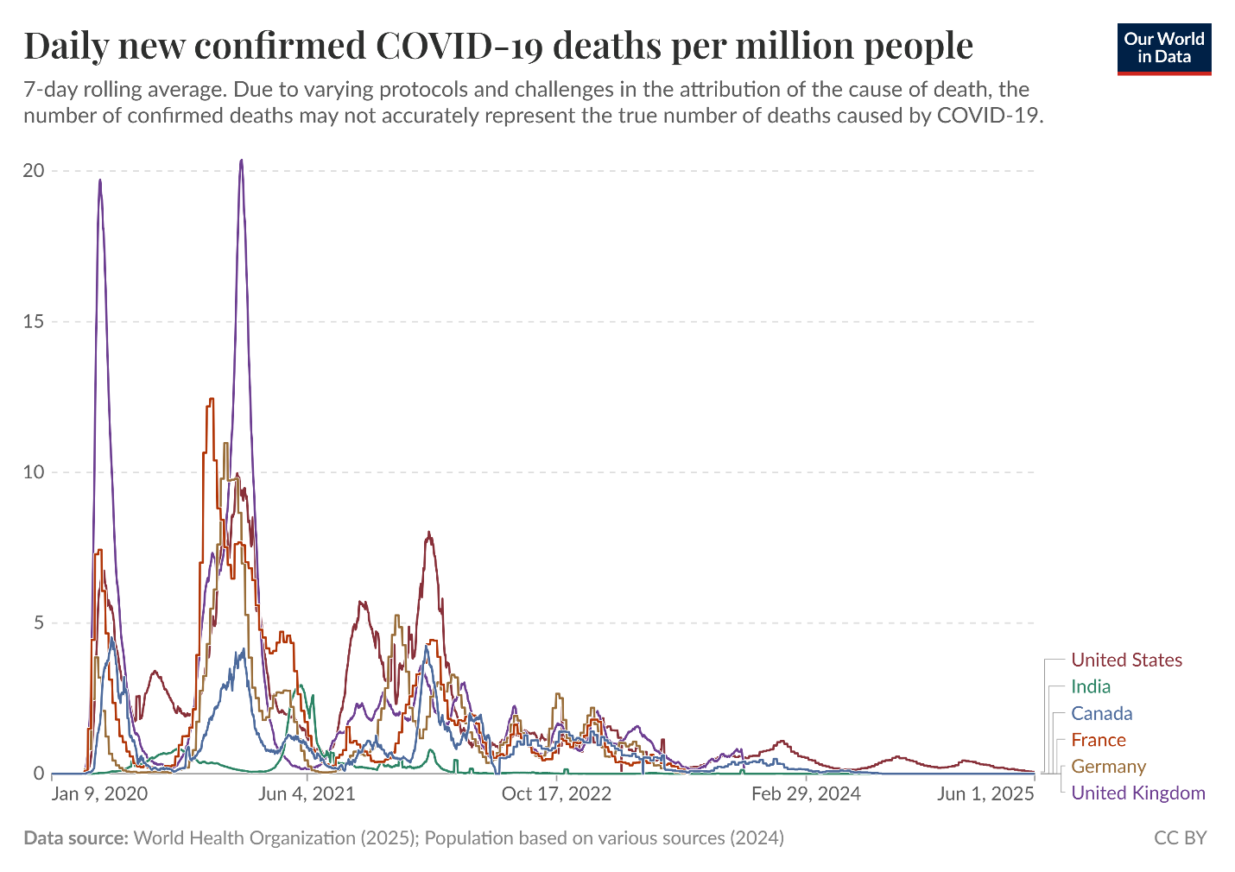

**Map :**

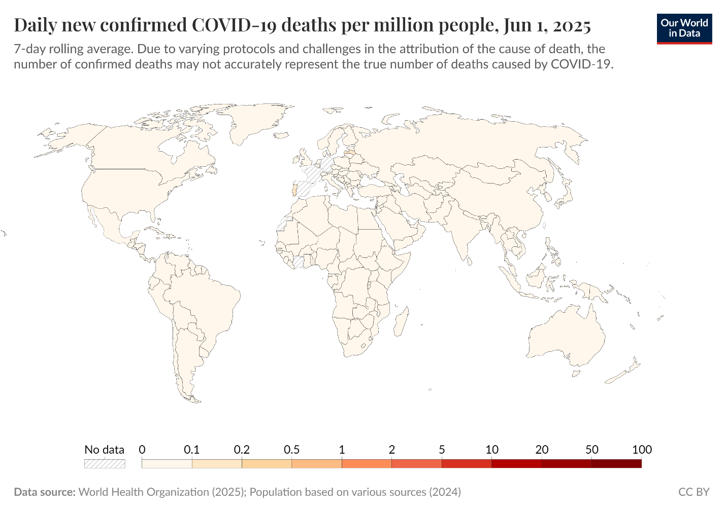

Data source: World Health Organization (2025); Population based on various sources (2024) – Learn more about this data.

**Three points to keep in mind about confirmed death figures**

* The actual death toll from COVID-19 is likely to be higher than the number of confirmed deaths – this is due to limited testing, poorly functioning death registries, challenges in determining the cause of death, and disruptions during the pandemic. The difference between reported confirmed deaths and actual deaths varies between countries.
* COVID-19 deaths may be recorded in different ways between countries (e.g., some countries may only count hospital deaths, whilst others also include deaths in homes).
* The death figures on a given date do not necessarily show the number of new deaths on that day, but the deaths *reported* on that day. Since reporting is delayed and the levels of reporting can vary between days, such as on weekends, regardless of any actual variation of deaths, it is more helpful to view the seven-day rolling average of the daily figures as we do in the chart here.

**Cumulative confirmed COVID-19 deaths by world**

**Region:**

Due to varying protocols and challenges in the attribution of the cause of death, the number ofconfirmed deaths may not accurately represent the true number of deaths caused by COVID-19.

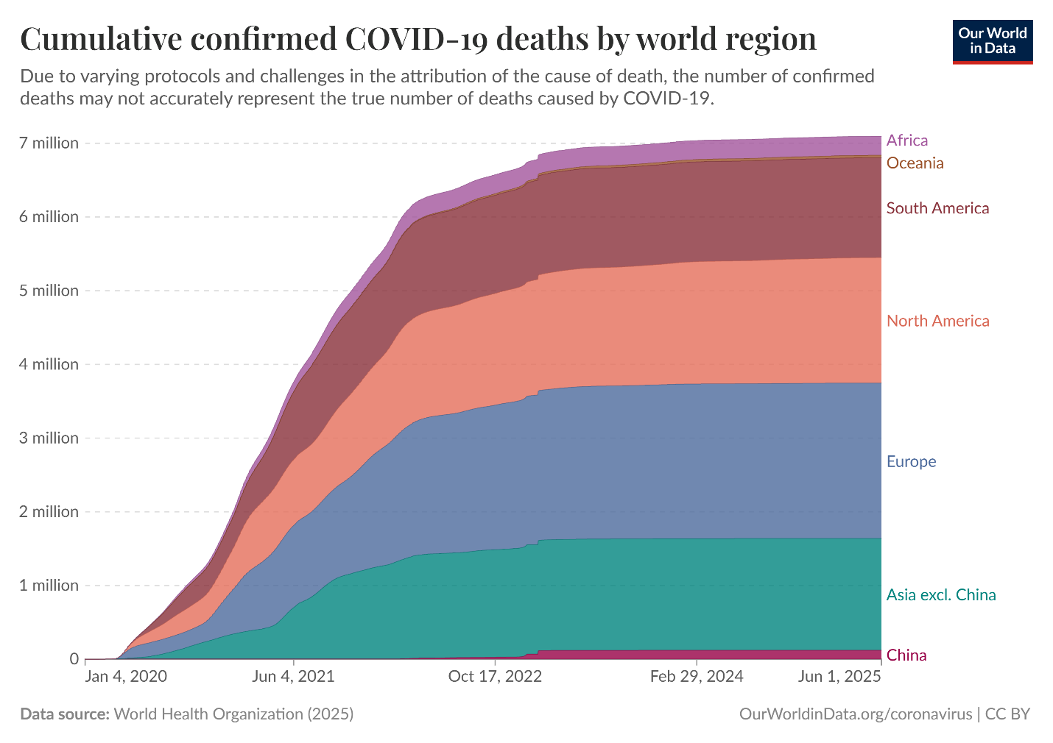

Keep in mind that some countries have limited testing and medical records, and/or poorly functioning death registries, so the actual number of deaths can be much higher than the number of confirmed deaths shown here.

**SQL Query Execution & Result Interpretation:**

**(1)Query:**

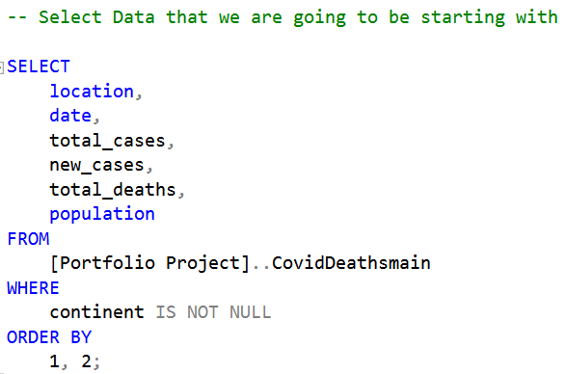

**Outcome:**

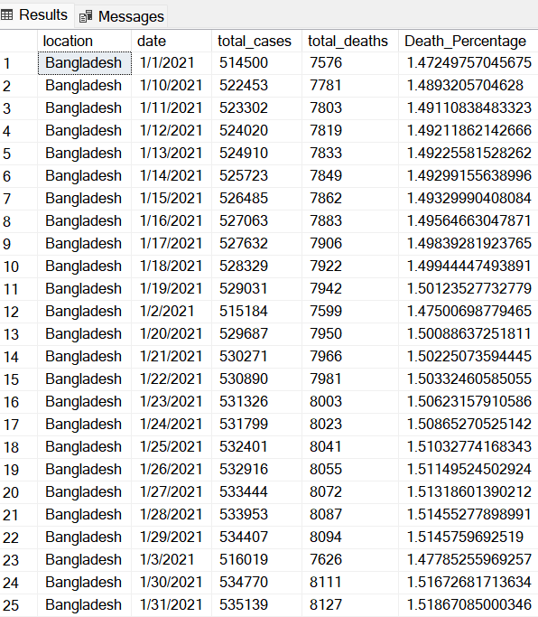

**COVID-19 Daily Cases and Deaths in Bangladesh (January 2021)**

This dataset details the daily confirmed COVID-19 cases, deaths, and corresponding death percentages in Bangladesh during January 2021. It demonstrates the progression of the pandemic within the country, highlighting small daily increases in deaths relative to total cases, offering insight into mortality trends during this period.

**(2) Query:**

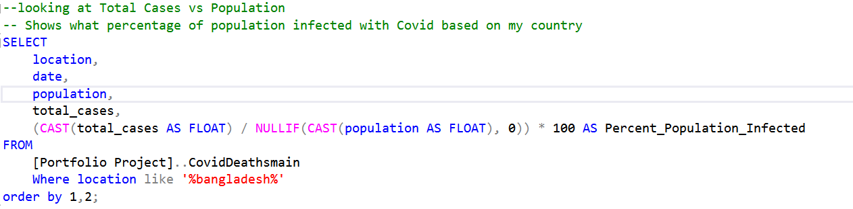

**Outcome:**

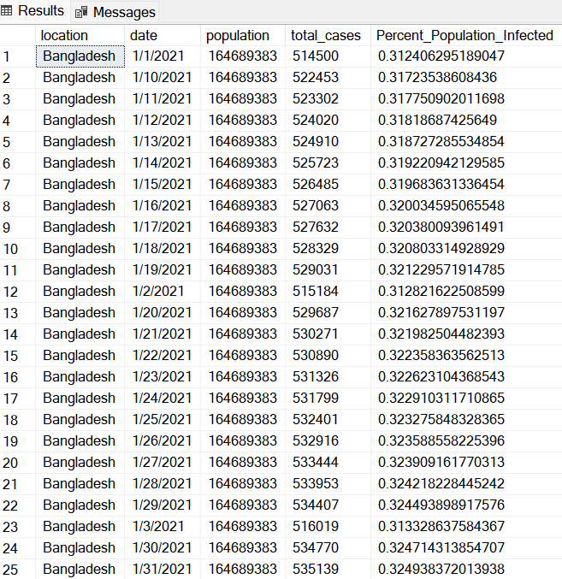

**COVID-19 Cases Relative to Population in Bangladesh**

This output shows confirmed cases alongside Bangladesh's population and calculates the percentage of the population infected over time in January 2021. This contextualizes the spread of the virus relative to population size, providing an understanding of prevalence and infection dynamics.

**(3) Query:**

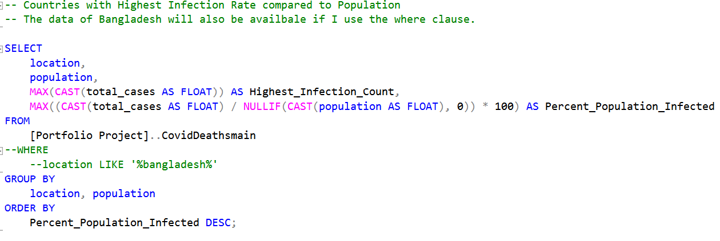

**Outcome:**

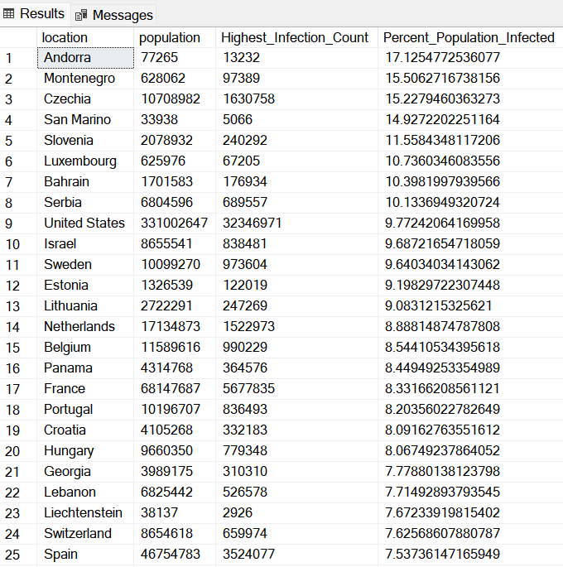

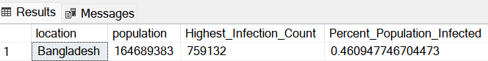

**Countries with Highest Infection Percentages**

A comparative analysis of countries with the highest percentage of their populations infected by COVID-19. The data includes total population counts, highest infection case numbers, and the infection percentage, ranking nations by their relative burden. This highlights countries like Andorra and Montenegro as severely impacted relative to population size.

**(4) Query:**

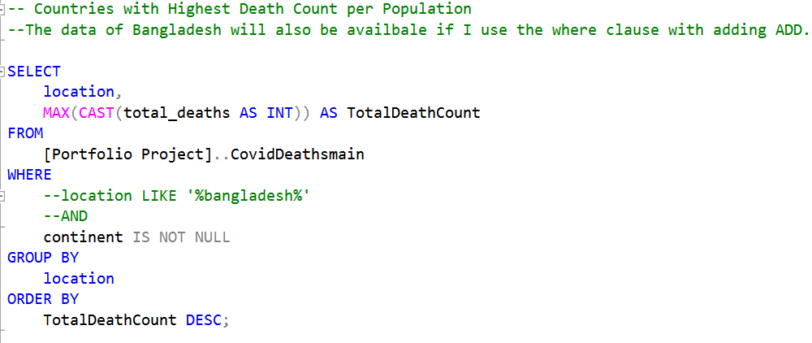

**Outcome:**

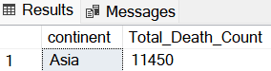

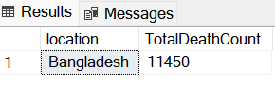

**Bangladesh Highest Infection Count and Percent Population Infected**

This summary highlights Bangladesh's peak infection count and infection rate as a percentage of the total population. It serves as a focused metric of the national pandemic burden in relative terms.

**(5) Query:**

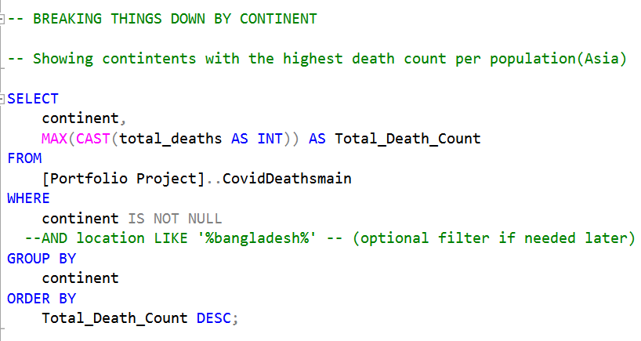

**Outcome:**

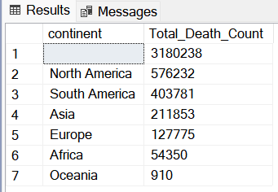

**COVID-19 Death Counts by Continent**

This dataset presents total death counts attributed to COVID-19, aggregated by continent. It provides insights into the global distribution of COVID-19 mortality, showing Asia with significant death counts.

**(6) Query:**

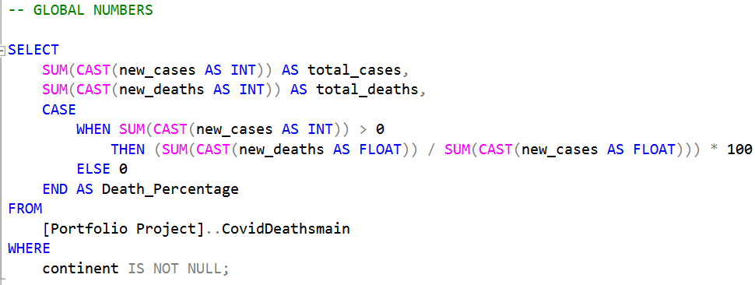

**Outcome:**

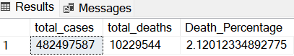

**Countries with Highest COVID-19 Infection Percentages**

Comparison of countries ranked by percentage of population infected, showing countries with notably high infection burdens.

**(7) Query:**

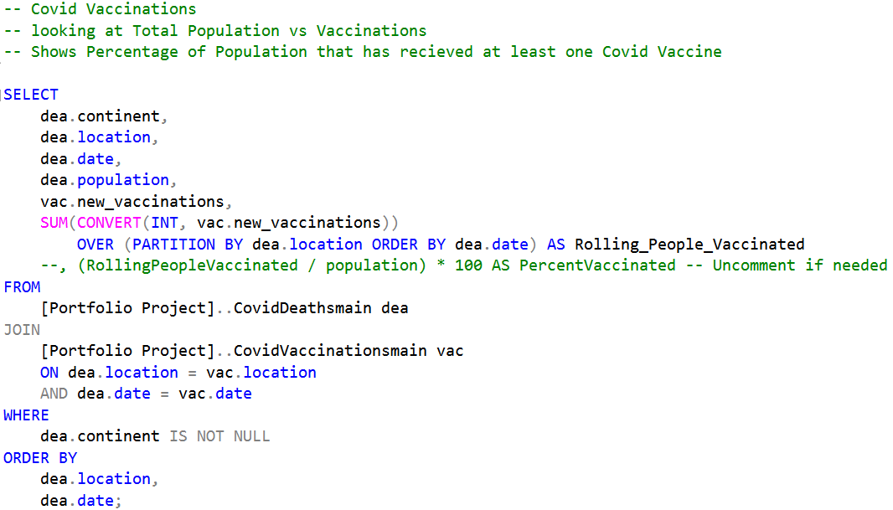

**Outcome:**

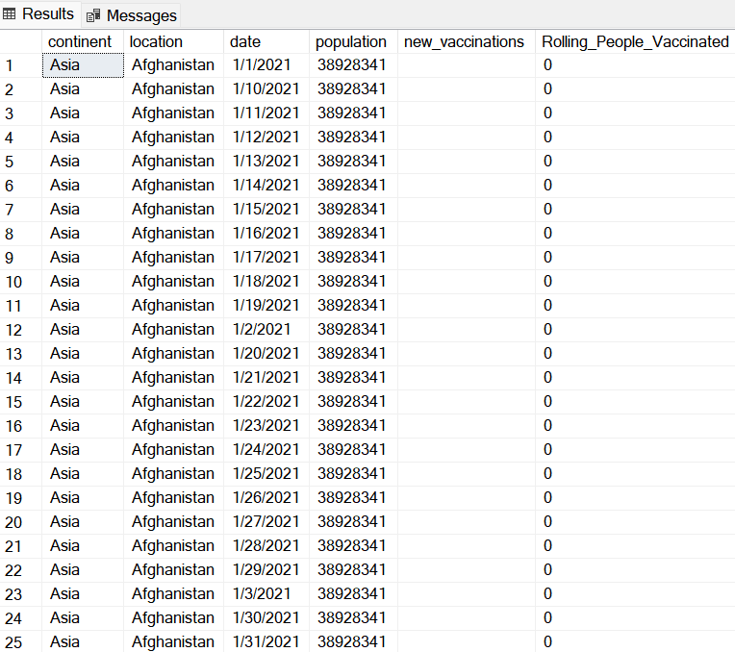

**Summary of Global COVID-19 Cases and Deaths:**Shows the total confirmed cases and deaths worldwide, along with the overall mortality rate, providing a comprehensive global impact overview.

**(8) Query:**

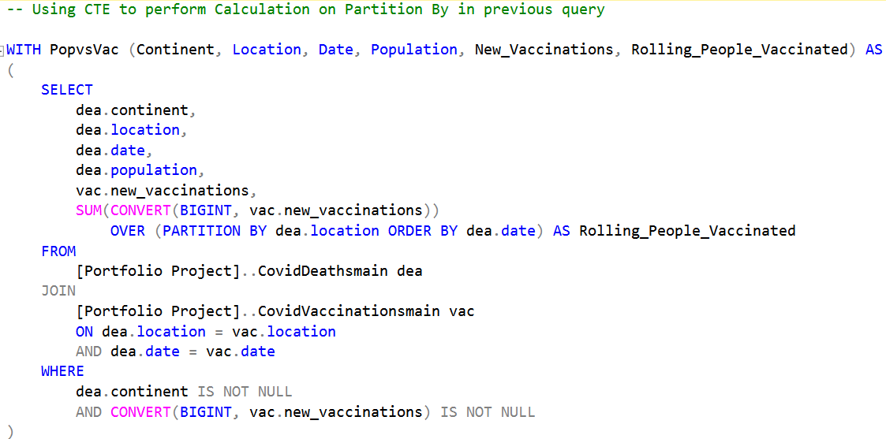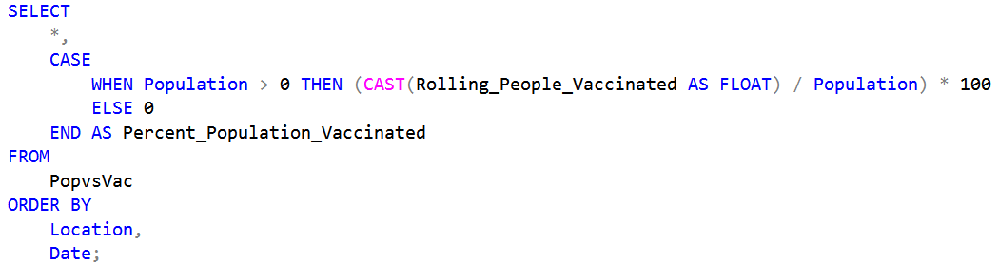

**Outcome:**

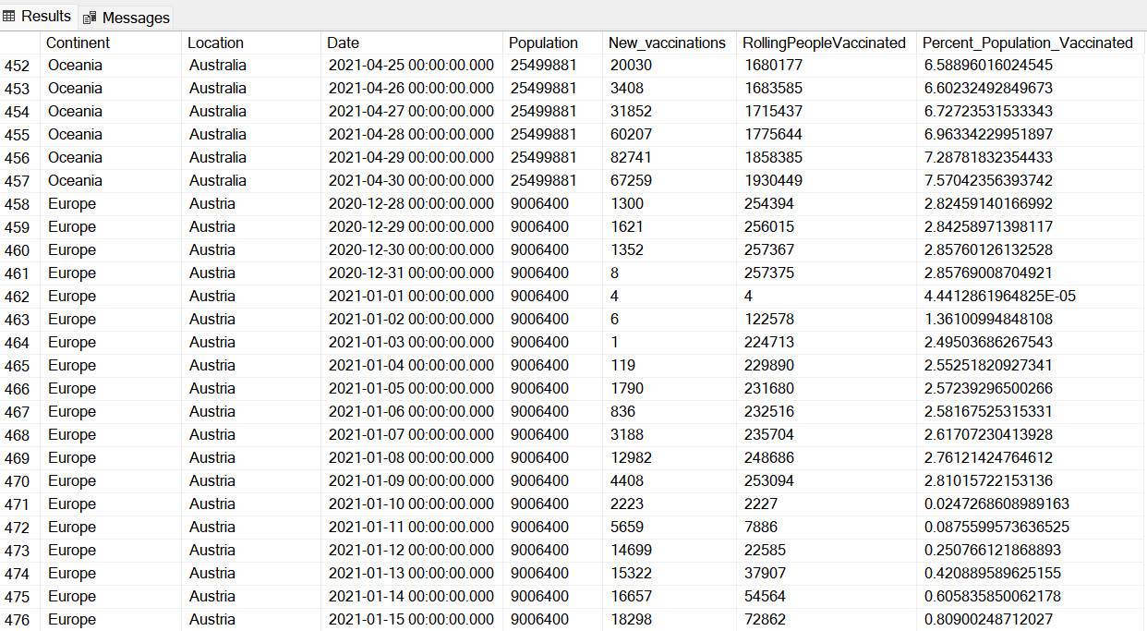

**Vaccination Data for Continent:**Displays daily vaccination counts and rolling totals for Continents illustrating the progression and scale of vaccination efforts during early 2021.

**(8) Query:**

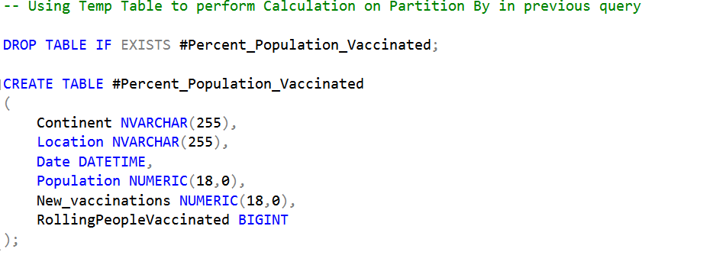

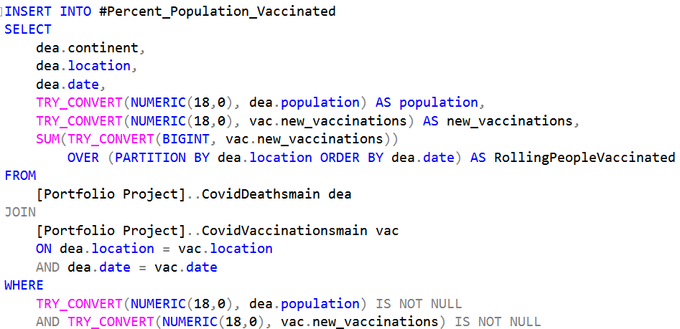

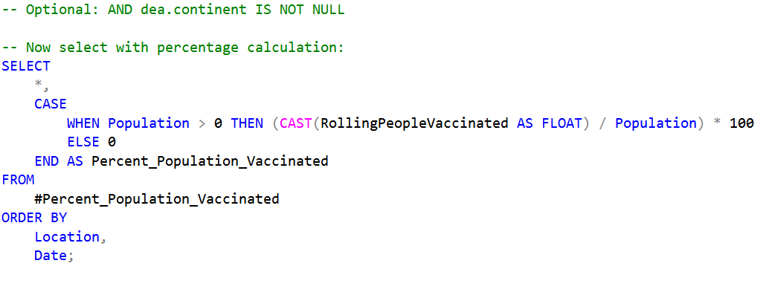

**Outcome:**

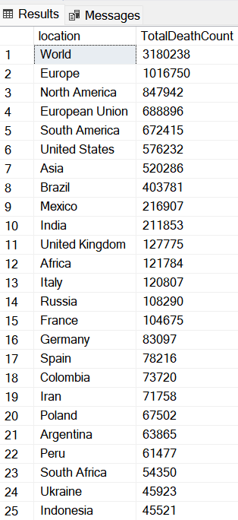

**Global COVID-19 Deaths by Continent:**Summarizes total COVID-19 death counts per continent, highlighting regional differences in pandemic mortality impacts.

**(9) Query:**

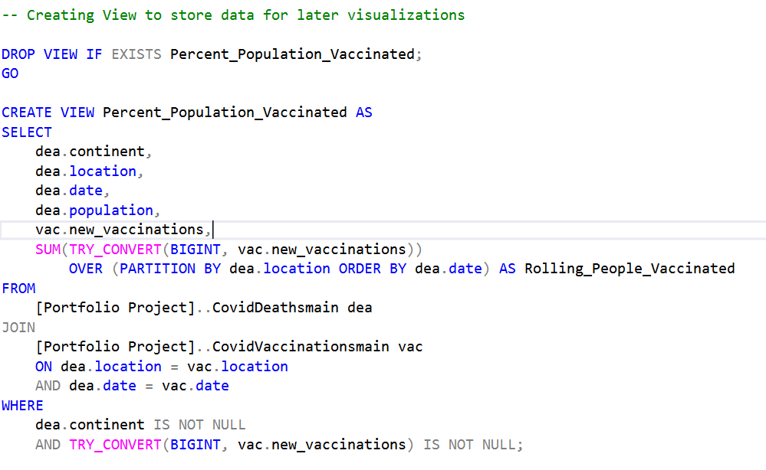

**Outcome:**

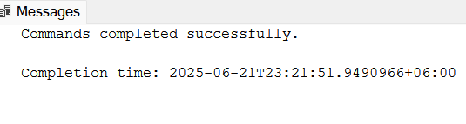

**Confirmation of Data Query Execution:**A system message confirming that all SQL commands and data retrieval processes completed successfully, ensuring data integrity.

**This project offers a comprehensive analysis of the COVID-19 pandemic by aggregating and visualizing data on confirmed cases, deaths, vaccination efforts, and regional impacts across the globe. Leveraging SQL queries to extract detailed insights, it highlights trends in infection rates, mortality, and vaccination progress in various countries and continents. Through systematic data processing, the project aims to inform stakeholders about the pandemic’s progression and regional disparities, providing valuable evidence for public health planning and response strategies.**